**Schedule Similarity**

***Prerequisite for Use***

This Preference requires that you have an initial customer schedule currently loaded.

***Work-flow to Use Schedule Similarity***

Use **Load Template** to set up and modify the preference for a variety of conditions



Repeat **Load Template** for additional instances of any template



***Preference Overview***

Using this preference, you can control the level of disruption to staff during a schedule change and indeed use it in stages to move from the supplied schedule to a fully optim- ized schedule.

This preference deals with **vehicle schedule similarity**. In what follows in this pref- erence, when we refer to a **schedule**, the intention is the **vehicle schedule** as seen in the Vehicles Gantt.



There is a corresponding preference for crew (driver) schedule similarity.

See **Crew Schedule Similarity**.

Optibus OnSchedule™ uses two criteria of similarity. The new **schedule** is similar to the

previous one if **either one** of the following hold:

**Trip ID similarity**: Consecutive trip IDs are substantially maintained.



A new schedule is *Trip ID simila*r to an existing schedule if the Trip IDs of any two con- secutive trips is maintained.

For example: If Trip ID Xis followed by Trip ID Y in the current schedule and Trip ID X

is still followed by Trip ID Y in the new schedule, this is considered to be *Trip Id similar*

and no penalty is imposed.

If however, if Trip ID X is followed by Trip ID Y in the current schedule but in the new schedule, Trip ID Xis followed by a different Trip ID Z, this considered to be a violation of Trip ID Similarity. Penalties will always be imposed for violations of Trip ID sim- ilarity.



The optimization takes the trips pairwise but no more.

**Trip start time similarity**: Trip start times are substantially maintained.



This is best illustrated by an example. Suppose that -

1. Trip ID X is followed by Trip ID Y in the current schedule

2. Trip Y starts at 09:30

3. Trip start time deviations of more than 10 minutes are considered to be viol- ations of Trip Start Time similarity

4. We require for trip similarity, that the trip following Trip ID X in the new schedule commence no earlier than 09:20 and no later than 09:40 and the route is the same as that of Trip Y.

5. A penalty *will be imposed* if either one of the following situations occur in the new schedule:

nThe route of the trip following Trip X has changed from the route of Trip

Y in the original schedule

nThe route of the trip following Trip X remains the same as the original

Trip Y but commences earlier than 09:20 or later than 09:40

Otherwise, we have maintained Trip Start Time Similarity for Trip X and the fol- lowing trip.

**About the imposition of penalties:**

The idea of "substantially" is implemented by applying a cost penalty for deviations from the original schedule as described above. Thus, if you impose a low penalty, you are effectively saying, "I would like the new schedule to be similar, but similarity is less important than my other preferences ." In this case, the optimized schedule may be

quite different from the original. If on the other hand, you impose a high penalty for devi- ations, you are effectively saying, "I would like the new schedule to be similar to the ori- ginal, if necessary at the expense of my other preferences ." In this case, the optimized schedule may not look very different from the original.

To demonstrate the concept, we will use the fourth template below, **Schedule Similarity**

**- by trip id**. It is the simplest to understand: It sets out to maintain Trip ID similarity. Its only parameter is the penalty. Here are results of setting increasing penalties as expressed by several KPIs:

*Table 1-1: Vehicle Schedule Similarity - KPI Partial Comparison for various penalties*

|  |  |  |  |  |  |  |
| --- | --- | --- | --- | --- | --- | --- |
| **KPI** | **Customer**  **Schedule** | **First Optim- ization** | **Penalty** | | | |
| **5** | **30** | **50** | **100** |
| Duties | 173 | 153 | 153 | 166 | 168 | 171 |
| Vehicles | 95 | 87 | 87 | 87 | 87 | 90 |

|  |  |  |  |  |  |  |
| --- | --- | --- | --- | --- | --- | --- |
| **KPI** | **Customer**  **Schedule** | **First Optim- ization** | **Penalty** | | | |
| **5** | **30** | **50** | **100** |
| **Vehicle Sim- ilarity** | **N/A** | **N/A** | **2%** | **29%** | **51%** | **78%** |
| Total Cost | 268,959 | 246,189 | 246,532 | 254,551 | 257,375 | 261,614 |

These results are for a specific schedule and are indicative only.

***Templates Available from Optibus***



*Table 1-2: Templates Summary*

|  |  |  |
| --- | --- | --- |
| **Template Name** | **Purpose** | **Reference** |
| Schedule Similarity - by route group & trip id | Create a new schedule to be **Trip ID - similar** to the sup- plied schedule but restricted to a nominated route group. | **Schedule Similarity - by route group &**  **trip id** |
| Schedule Similarity - by route group & time | Create a new schedule to be **Trip Start Time - similar** to the supplied schedule for the nominated route group. It attempts prevent trip start time deviations of more than the specified time. | **Schedule Similarity - by route group & time** |
| Schedule Similarity - by route & time | Create a new schedule to be **Trip Start Time - similar** to the supplied schedule for the nominated route. It attempts prevent trip start time deviations of more than the specified time. | **Schedule Similarity - by route & time** |
| Schedule Similarity - by trip id | Create a new schedule to be **Trip ID - similar** to the sup- plied schedule. | **Schedule Similarity - by trip id** |

Create a new schedule to be **Trip ID - similar** to the supplied schedule but restricted to a nominated route group.

**Prerequisites:** You should have already defined your route groups. See Miscellaneous

Preferences, **Route Groups**.

**Opening Dialog:**

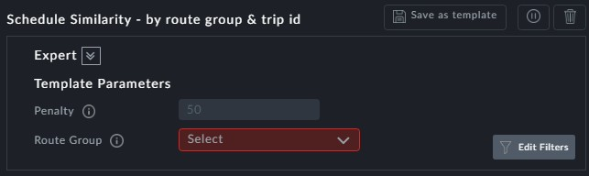

**Points to note:**

**Route Group:** The **Route Group** field is mandatory



**Penalty**: A high similarity carries a high penalty



Load this template again to for additional route groups



Create a new schedule to be **Trip Start Time - similar** to the supplied schedule for the nominated route group. It attempts prevent trip start time deviations of more than the specified time.

**Prerequisites:** You should have already defined your route groups. See Miscellaneous

Preferences, **Route Groups**.

**Opening Dialog:**

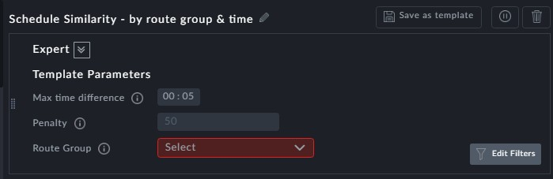

**Points to note:**

**Max time difference**: This is the maximum time deviation between the start time of a trip on a specific route as between the original schedule and the optimized sched- ule - that can be considered *Start Time Similar*



**Penalty**: The penalty is imposed when the **Max time difference** is exceeded. A high similarity carries a high penalty



**Route Group**: The **Route Group** field is mandatory



Load this template again to for additional route groups and/or times



Create a new schedule to be *Trip Start Time - similar* to the supplied schedule for the nom- inated route. It attempts prevent trip start time deviations of more than the specified

time.

**Prerequisites:** None.

**Opening Dialog:**

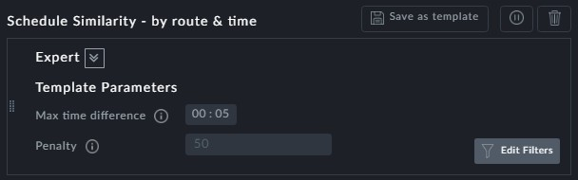

*Figure 1-1: Schedule Similarity by route and time*

**Points to note:**

**Max time difference:** This is the maximum time deviation between the start time of a trip on a specific route as between the original schedule and the optimized sched- ule - that can be considered *Start Time - similar*.



**Penalty**: The penalty is imposed when the **Max time difference** is exceeded. A high similarity carries a high penalty



You can create additional instances of this template using **Edit Filters** to differentiate between them.



Create a new schedule to be **Trip ID - similar** to the supplied schedule.

**Prerequisites:** None.

**Opening Dialog:**

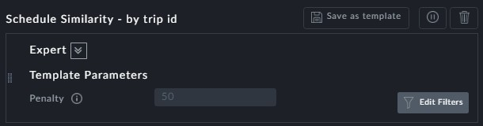

**Points to note:**

**Penalty**: A high similarity carries a high penalty



You can create additional instances of this template using Edit Filters to differentiate between them.



**Example:**

See **Preference Overview** above.